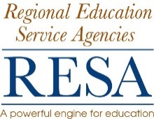 | RESA SCHOOL BUS OPERATOR TRAINING  CLASS EVALUATION FORM

Please help us continue to provide quality school bus operator training.
Check the box which best responds to the statements on the left side and list
suggestions for program improvement on # 13. Use the back of the form if necessary.
 | Very satisfied Less satisfied
 | 5 | 4 | 3 | 2 | 1
1. The trainer treats student fairly.
2. The trainer provides individual assistance.
3. The trainer gives clear directions.
4. The trainer provides a variety of activities.
5. The trainer knows the subject matter.
6. The trainer comes to class well prepared.
7. The trainer encourages student participation in class.
8. The trainer is able to communicate ideas clearly.
9. Equipment is adequate and ready to use.
10. The trainer uses audiovisual appropriate to class.
11. The trainer helps us get the most out of each hour.
12. Class begins on time.
13. Please list suggestions for improving the class (use the back if needed).

Trainer:
Date:
Name (optional):

