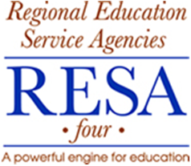

Media Release Form

RESA 4 staff disseminates a quarterly newsletter which features our work in our six-county region. At times this will include taking pictures and/or videos to help document our work.

Since implementing the Bus Operator Training, we would like to give credit to all Transportation Directors, Trainers and State Examiners that facilitate the training process. Also if you are a student participating in a training class, you may be in a picture. If you appear in a picture or video, RESA 4 would like to be able to publish those images in media such as Power Point presentations, newspaper articles, brochures, newsletters and web pages. Please sign below to give us permission to include pictures in which you appear.

__________________________________________________________
Printed Name

__________________________________________________________
Signature Date

